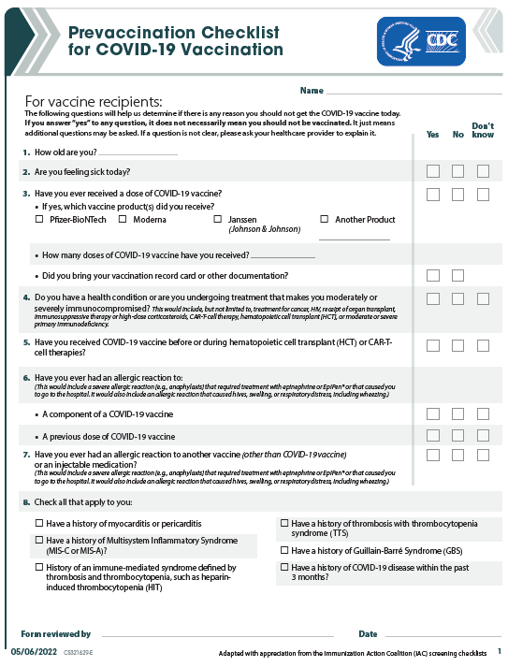

Recipient Name: First___________________________Middle____________________Last________________________________
Date of Birth _____/_____/______ Recipient Email Address: ________________________________ ☐ No email

Recipient Race: ☐ American Indian/Alaska Native ☐ Asian ☐ Black/African American
☐ Native Hawaiian or Other Pacific Islander ☐ White ☐ Other ☐ Unknown

Recipient Ethnicity: ☐ Hispanic or Latino ☐ Not Hispanic or Latino ☐ Unknown

Recipient Gender: ☐ Male ☐ Female ☐ Other ☐ I do not want to specify
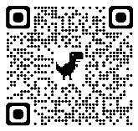
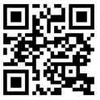
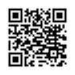
I certify that I am able to consent for this COVID19 vaccine against this communicable disease or I am the parent or legal guardian of the above named patient if they are a minor. I consent to receive the vaccine and for my demographic and health condition information to be shared with the COVID-19 Management System (CVMS) as required. I have received a copy of the Emergency Use Authorization Fact Sheet on the Pfizer COVID-19 vaccine (QR code 5-11 yr old is top right and 6mo-4 yo is middle). I acknowledge that I have been advised to remain near the vaccination location for approximately 15 minutes (or more in specific cases) after administration for observation. If I experience a severe reaction after leaving the office, I will call 911 or go to the nearest hospital. Bottom right QR for V-Safe tool to connect to CDC about your vaccine.

I authorize payment from private Insurance or Medicare/Medicaid to be made on my behalf to the licensed healthcare provider administering the vaccine for services provided. I understand that my signature below will serve as legal “signature on file” for purposes of filing insurance/Medicaid claims and payment of benefits to Pediatric Partners. THE COVID VACCINES ARE FREE TO EVERYONE, REGARDLESS OF WHETHER YOU HAVE PRIVATE OR GOVERNMENT INSURANCE OR NO INSURANCE AT ALL. No out-of-pocket cost to you by Federal Law!

Signature _______________________________________________________________Date ________________
Print name________________________________________________________ (Parent/guardian must sign if <16 yo)
Site of Injection: ☐ Right Deltoid, IM ☐ Left Deltoid, IM ☐Other________ ☐ 1st dose ☐ 2nd ☐ 3rd ☐ Booster
Administration Date: _____/_____/_________ Time: _____________________ Pfizer COVID19 vaccine (COMIRNATY)
Lot #: _______________________Exp: _____/_____/_______ Vaccine administered by:_______________________
Patient ID#_________ Athena NCIR

